BIO DATA
Name : EMMADI SRIDEVI
PH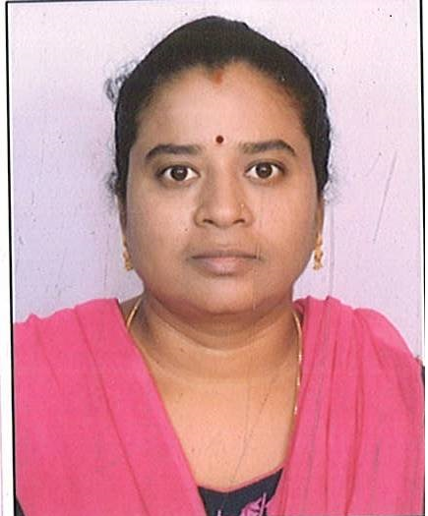OTO
Mobile No : 8328099978
Email ID : SRIDEVIBHEL@GMAIL.COM
Gender : FEMALE
Date of birth : 05-05-1981
Nationality : INDIAN
Religion : HINDU
Father’s name : VENKAIAH
Mother’s name : KAMALA
Languages Known : TELUGU
Hobbies : READING
Address : Q.NO.2067/C, BHEL TOWNSHIP,
RAMCHANDRAPURAM, HYDERABAD - 502032

*EDUCATIONAL BACKGROUND
High School : SSC Year of passing: 1996
College : MPC Year of passing: 1998
Other Courses : MA ASTROLOGY Year of passing: 2008

Place: BHEL, HYDERABAD
Date: 23-08-2023

